Year 1 Home learning 29.3.22

Maths – Measuring Mass
Number bonds quiz – how many can you answer in 1 minute?

Watch the White Rose Maths teaching video https://vimeo.com/517199752 and complete worksheet (see PDF)

English (Blue/Yellow Groups)
Listen to Mrs Cangiano read ‘Emma Jane’s Aeroplane’. Emma Jane's Aeroplane
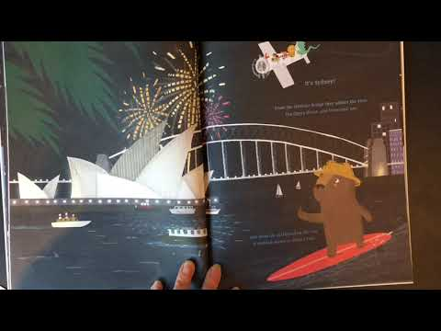

Story planning – Imagine you travel around the world like Emma-Jane. Where will you go? Use the template to draw a story map, visiting different places and picking up animals on the way. Will you fly, cycle, sail or drive? Maybe you’ll travel by horseback or rowing boat? Maybe you’ll have a bicycle with 6 seats? It’s up to you. Draw some pictures of places and animals today so that you can turn them into a story on Wednesday and Thursday.

P.E.
In school, we will be practising gymnastics skills. If you feel well enough, try the activities (see separate PDFs).

Music
In school, we will be listening to music and clapping, stomping (or playing instruments) to the pulse. We will also be copying different rhythms. You can listen and ‘stomp’ along with the band:
https://www.bbc.co.uk/teach/bring-the-noise/primary-music-yolanda-brown-funky-elephant/zftq47h

Then you can play the game below:
https://www.bbc.co.uk/teach/bring-the-noise/eyfs-ks1-music-play-it-bring-the-noise/z4sq92p
- Click on ‘Play it’
- Click on ‘Feel the beat’
- Choose a song
- Press ‘play’ to start the song
- Clap or play an instrument to the pulse (saucepan, bucket, pile of books and a wooden spoon)

